Dear Guest,

AlvorMar Apartments has an agreement with a Laboratory in Alvor and Portimão, which offers special prices, for our guests who require to present a covid-19 clinical test for flying in a specific airline company or to present when re-entering their country.
Guests schedule their tests directly by visiting the website www.jcs.pt and they will be charged the reduced price when presenting a paper our reception desk will provide them with.
To ensure test booking availability we recommend you to book your test in advance before arriving. You can also let us know your test date so we can have your paper filled out and ready for you at the time of check-in. You just need to send us the following information: name as in passport, e-mail, date and hour of departure flight.
We advise you, before scheduling your test, and to avoid constraints with your return trip, to obtain confirmation both from your airline company and from your country’s government on which type of test you need to present (PCR or Antigen). Please note, that if a test needs to be done 72 hours (for example) before you re-enter your country, the day and time you take the test should be taken into account not to overpass those 72 hours.
Relevant Information
Collection stations names and addresses:
Joaquim Chaves Saúde in Portimão
Largo D. João II, 8500-533 Portimão
Contact: 282 413 363
Joaquim Chaves Saúde in Alvor
Rua 25 Abril, 15 RC Direito
Contact: 282 413 363
Sample collection days:
PCR test - from Monday to Saturday
Antigen test – from Monday to Friday
Sundays – Closed

Test Types and prices:
PCR test – 65€
Antigen rapid test – 30€
Time taken to receive results:
PCR test – when done on weekdays (save unforeseen situations), results will be ready until 14h00 (2pm) of the day following the day the test was done. When done on Saturdays results will be ready until 12h00 (noon) of the following Monday.
Antigen tests – results will be ready within a maximum of 24 hours (normally on the same day the sample is collected).
Please be aware of this information when scheduling your test.

Procedure COVID-19 Test

1st
Scan the QR code using your smartphone or just access https://www.jcs.pt/en/exames_covid

2nd
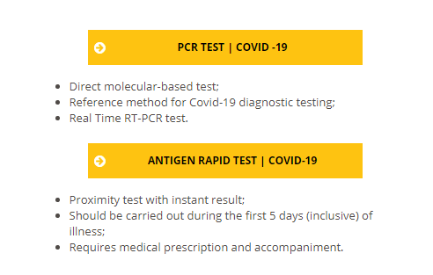
Choose between PCR or Antigen test:

3rd
PCR Test:
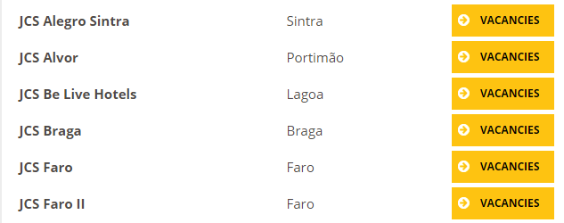
Go to Page 1 and click on Vacancies in Alvor

Antigen Test:
In the end of page 1 click on Vacancies in Alvor
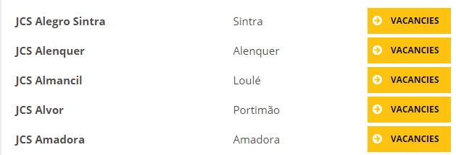

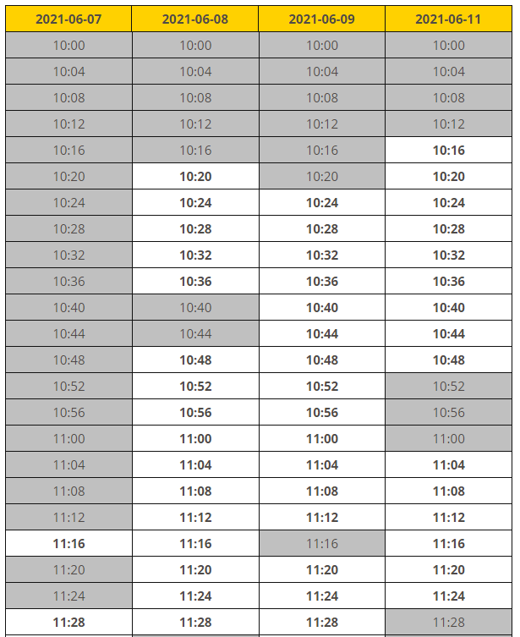
4th

Chose the day and time.
The times in grey are fully booked therefore they
can’t be selected.
Bookings are made separately
(1 person per booking).
Please make sure you get there at least 15 min
before.

5th
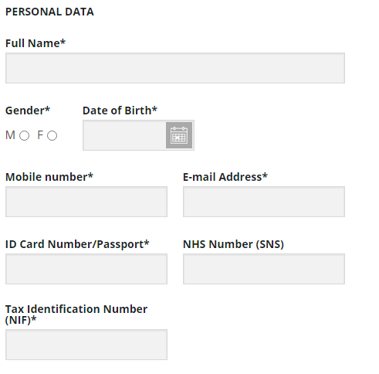
Fill all the missing data

And click on “SUBMIT BOOKING”

6th
Check your e-mail for the confirmation of your booking and ask the front desk for the paperwork needed to present on your arrival at the laboratory.

